Subsequence and Subsets

Number of Subarrays: ( n \* (n+1)) / 2

Number of Subsequence: 2 pow N

Number of Subset: 2 pow N where n have distinct element

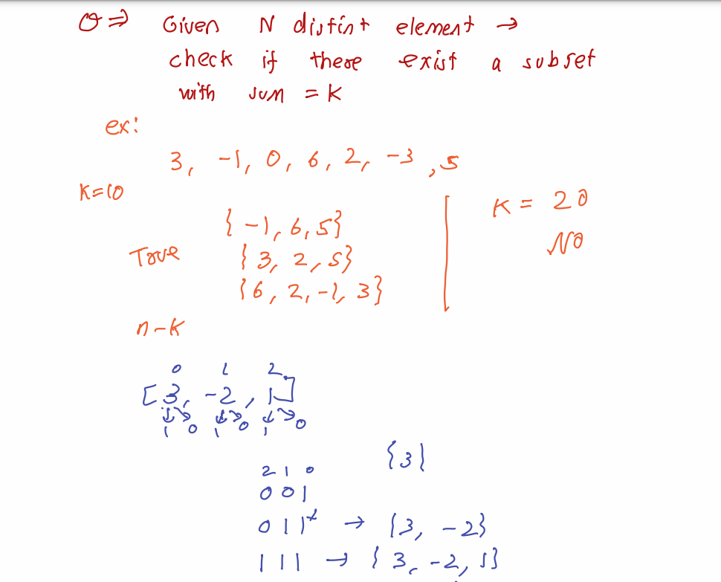

Note: Sum of all subset = sum of ( element \* 2pow n-1)